Discourse #4/Greek and Roman Art
Greek Classicism
The iconic Renaissance sculpture, David, by Michelangelo, can be seen at the Museo Accademia in Florence, Italy. During the Renaissance there was a return to Greek classicism although the period had innovations of its own. All I want you to do is examine David for classical canons. Name the canons and apply them to the sculpture as you describe it. Don’t get carried away discussing the Biblical story; only discuss what you see in the sculpture. Again, I am interested in the stylistic issues as they relate to the culture. Here I am interested in the Greek culture, not the Renaissance culture; we will get to it in a couple of weeks. Again, I want you discuss the influences of the Greek culture on this sculpture. (one page)

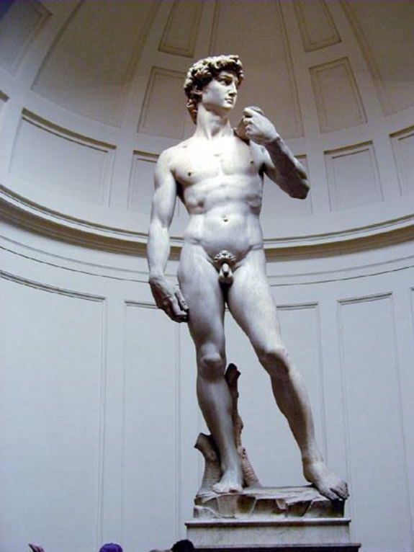
Statue of David

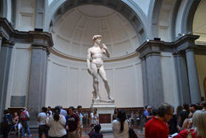

Roman Busts
The sculpture below is a Roman Bust. Busts were an art form that was found in the homes of average Romans. They consisted of heads from the shoulder up or neck up and the subjects were family elders, civic leaders, or war heroes. Unlike the Greeks who depicted their elders with an idealized youthful face despite their age, Romans respected their elders for their wisdom and experience. The Romans also were proud of Rome so much so that they wanted to remembered for being an individual Roman who really walked the earth, for posterity. The rest you can learn from your textbook, but I wanted to emphasize the Roman Bust here. Notice the wrinkles, the scowl, the large nose, all individual traits of this particular man.

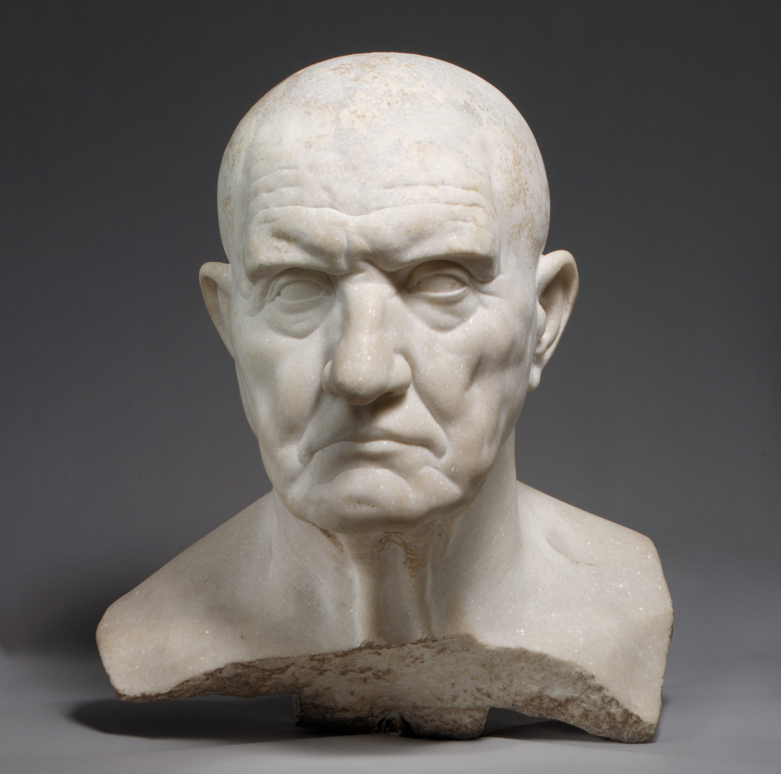
Roman Bust

